Daily Report
Date : 02.02.26
Task Report: Project & Board Data Models and CRUD APIs
Created Mongoose data models for Project and Board, establishing a relationship where a project can have multiple boards. Designed schemas with required fields and references to maintain data integrity. Implemented full CRUD (Create, Read, Update, Delete) REST API endpoints for projects using Node.js, Express, and Mongoose. Tested all endpoints to ensure correct database operations and proper response handling.
Screenshots :
Models:
BoardSchema:
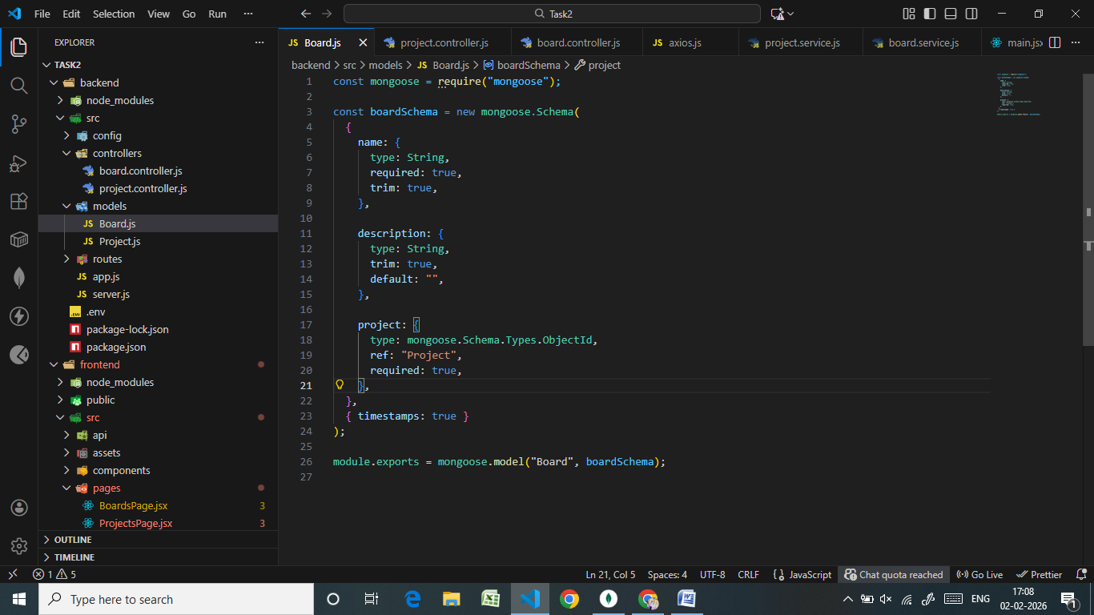

ProjectSchema:
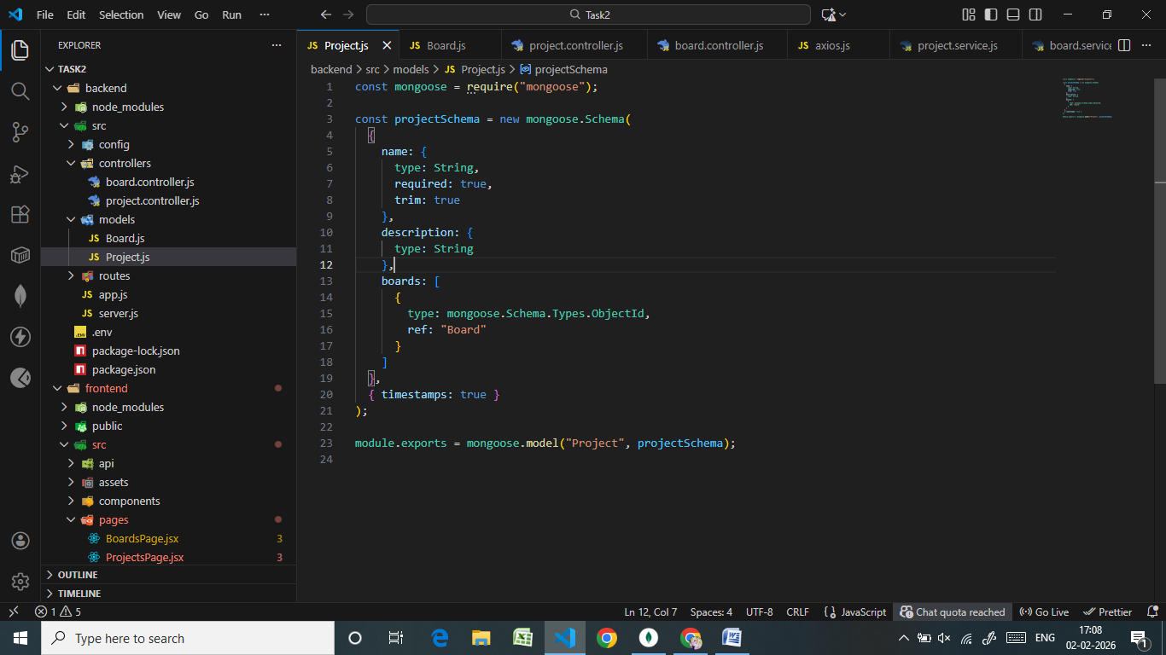
MongoDB Connection
Board :
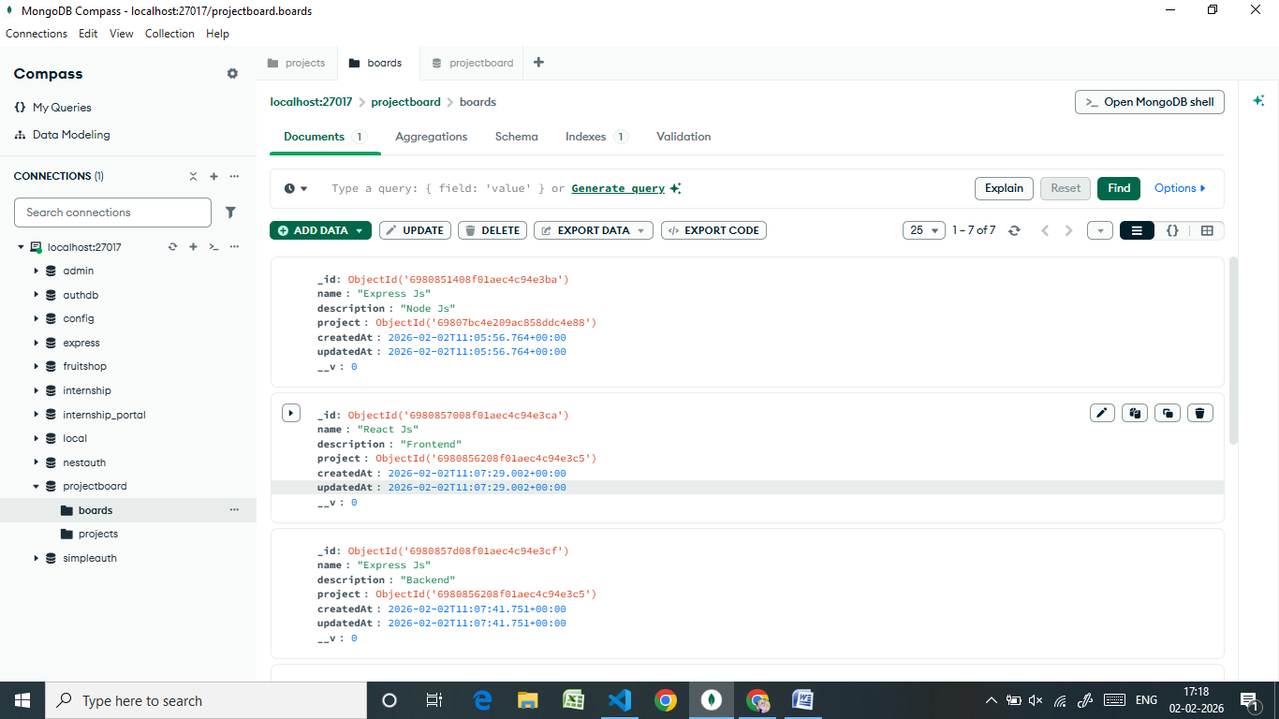
Project:
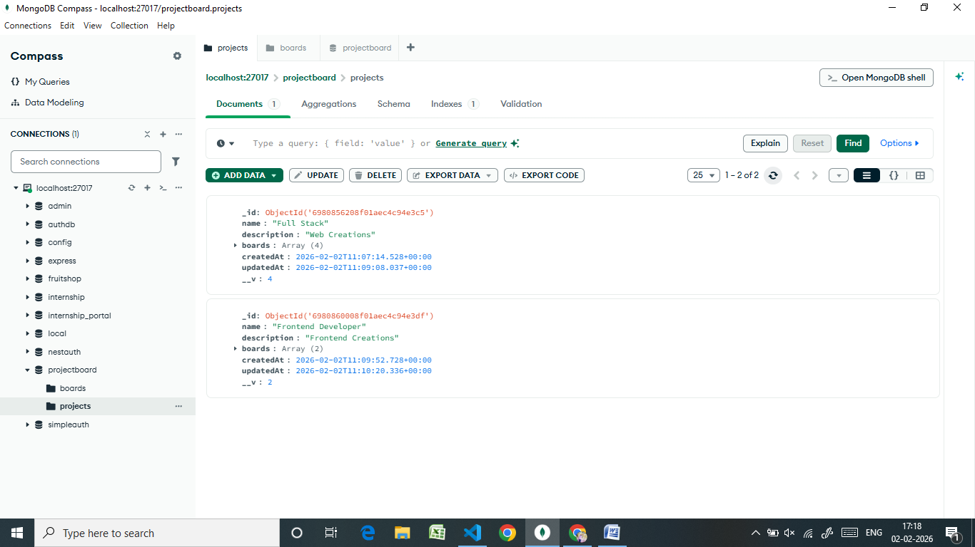

Controllers:
Board Controller:
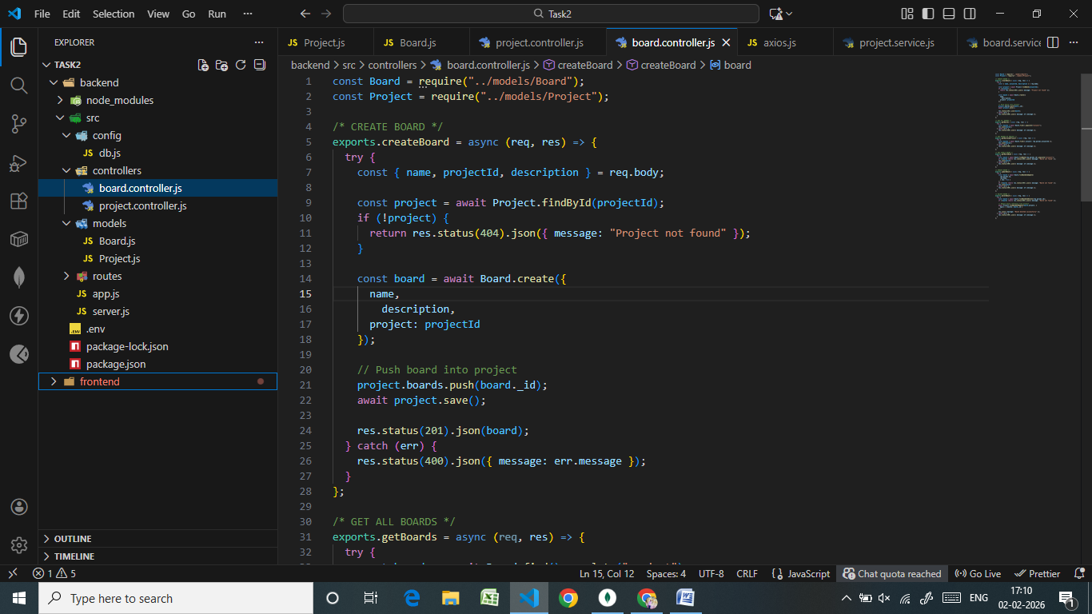

Project Controller:
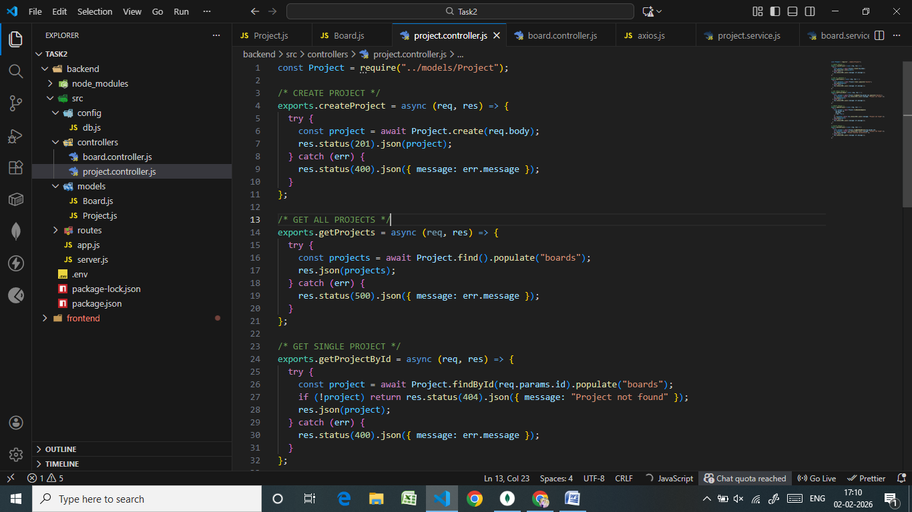
Routes:
Board Routes:
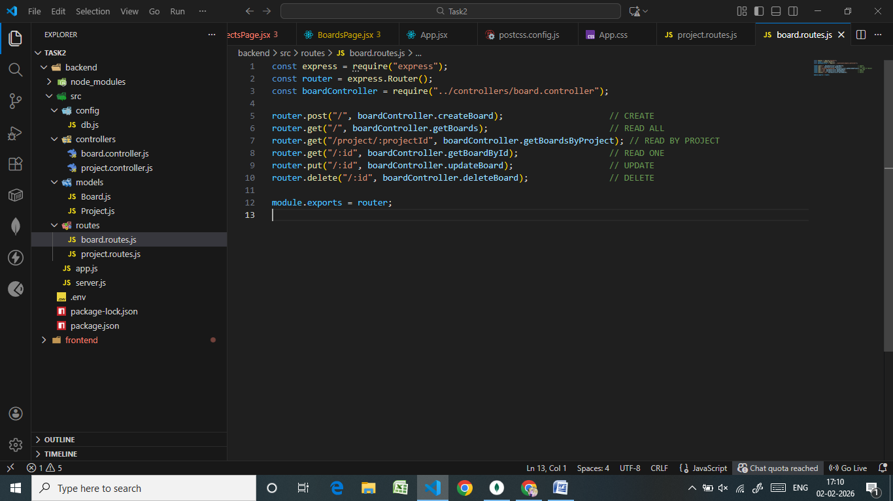
Project Routes:
